How to limit the computer in LAN to access some websites through URL filter
Product line: Wireless question category: function config
Q：What is URL Filtering for?
A：By URL Filtering, we can forbid some devices in LAN to access some websites in specified time.

Steps are as following:
1. Login the management page of the router.

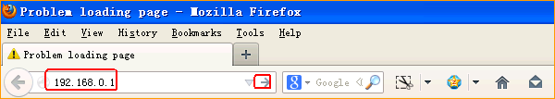

2. Input login password admin(default), to login, then click Advanced
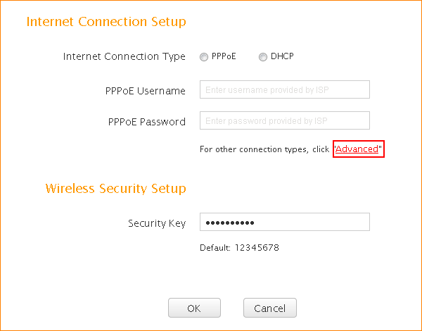
- Click on Security, then go to URL Filter Settings

If you want to forbid your children whose computer’s IP address is 192.168.0.100-192.168.0.103 to access the website that include ‘google’ from Monday to Friday,you can do the settings as the following picture.
